**Title:** **INSTRUCTIONS FOR THE PAPERS WRITING IN COMMUNICATIONS - SCIENTIFIC LETTERS OF THE UNIVERSITY OF ZILINA**

*Author (Name, Middle name, Surname)1,*, Author2, ….*

1Affiliation (with full address): Department, Faculty, University, Street, Town/City, Country, E - mail

2Affiliation (with full address): Department, Faculty, University, Street, Town/City, Country, E - mail

…

*E-mail of corresponding author: e-mail of corresponding author

Authors´ORCID IDs:

Please provide authors´ORCID IDs if they exist. Submitted and verified ORCID IDs will appear on the article: on PDF file, on the website and in the underlying metadata XML submitted to Crossref DOI. The authors who already have an ORCID ID can submit it along with their name, when submit their manuscripts. Getting an ORCID ID is free and easy to do through the ORCID registration page.

**Abstract:** The abstract should not exceed 10 lines.

**Keywords:** Please provide keywords which express the principal topics of the paper.

**1 Introduction**

All papers have to deal with the topic of transport and be submitted strictly within one of the listed subtopics. Please, refer to list of topics and subtopics here and indicate it clearly when submitting your paper.

Submitted papers must be unpublished and must not be currently under review for any other publication.

Manuscripts written in good English must include abstract and keywords also written in English.

The resume (abstract) should not exceed 10 lines.

Please provide minimum three up to maximum seven keywords which express the principal topics of the paper.

Submitted manuscripts must not exceed 15 pages (including figures, graphs, list of references, appendix, etc.). The cost of one additional page, designed according to the requirements of the journal, is 50.00 Euro.

The nomination of 2 reviewers must be enclosed - their full names, workplaces and e-mails must be sent. Please provide their personal email accounts (e.g. Gmail/Yahoo/Hotmail) only if their institutional email accounts can be found after performing a basic Google search (name and institution). Submit reviewers suggestions of scientists from different countries than those of the authors.

For all manuscripts a standard single-anonymised peer review procedure by at least two independent reviewers and language correction is mandatory.

After reviewing and incorporating the editor‘s comments, the final draft (before printing) will be sent to authors for final review and minor adjustments.

**2 Journal topics**

General journal focus area - Transport research and engineering

Main topic: Operation and Economics in Transport

Subtopics:

Transport Policy

Markets with Transport and Postal Services

Benchmarking of Transport and Postal Enterprises

Logistics in Transport

Transport systems in Countries, Regions and Cities

Quality in Transport and Postal Services

Operational Models in Transportation and Posts

Main topic: Mechanical Engineering in Transport

Subtopics:

Materials and Technology in Transport

Modelling and Simulation in Transport

Mechatronics, Robotics and Automation in Transport

Thermodynamics, Energy and Environment in Transport

Kinematics, Dynamics and Control of Mechanical Systems in Transport

Design, Manufacturing and Product Development in Transport

Surface Engineering in Transport

Industrial Engineering in Transport

Automotive in Transport

Main topic: Electrical Engineering in Transport

Subtopics:

ICT (Information and Communication Technologies) in Transport

Power Electronics and Autotronics in Transport

Power Electrical Systems in Transport

Control and Information Systems in Transport and Industry

Materials and Technologies for Transport

Robotics and Cybernetics in Transport

Mechatronics in Transport

Main topic: Civil Engineering in Transport

Subtopics:

Transportation Infrastructure - Bridges

Transportation Infrastructure - Roads

Transportation Infrastructure - Railways

Transportation Infrastructure - Geotechnics

Transportation Infrastructure - Construction

Transportation Infrastructure - Mechanics

Transportation Infrastructure - Buildings

Transportation Plannig and Engineering

Transport and Environment

Main topic: Management Science and Informatics in Transport

Subtopics:

Optimisation and Simulation Methods in Transport

Intelligent Transport Systems and Networks

Information Systems in Transport

Geoinformatics and GIS in Transport

Computer Science for Transport

Main topic: Safety and Security Engineering in Transport

Subtopics:

Critical Infrastructure in Transport

Emergency and Crisis Management in Transport

Accident Response in Transport

Risk Assessment in Transport

Fire Safety in Transport

Security Management in Transport

Main topic: Travel and Tourism Studies in Transport Development

Subtopics:

Place Branding and Comparative Advantage - the Infrastructure

Co - Creation as a Possibility of Transportation Improvement in Cities

Inovations, Creativity and New Forms of Communication in Cities

All papers have to be submitted within one of the above subtopics.

**3 General paper format**

Submissions should be prepared in Microsoft WORD compatible format – format A4, Times Roman size 12, double line spacing, page margins 2.5 cm.

Do not use styles and limit formating to minimum (bold for section headings, figure and table captions).

Uncommon abbreviations must be defined the first time they are used in the text.

**3.1 Equations, mathematics and number formats**

Mathematical symbols and equations should follow standard formatting rules (use of italics and bold) and the use of inline mathematic equations and expressions limited to a necessary minimum.

Scalar variables in the text are set as italic (e.g. *rcorr* or *A5*), vector are set as boldface (e.g. **F**, **a** or v1) and matrices or tensors are set as boldface Arial (e. g. **Z**).

Use decimal point instead of decimal comma in numbers, e.g. 0.367 and not 0,367.

All equations, with the exeption of inline expressions, should be numbered in a chronological order using numbers in brackets - (1).

Equations may be submitted in only in Word and Mathtype formats and must be editable, i.e. not embeded as figures.

Only SI units are allowed, using multiplication and negative powers instead of /, e.g. kg.m-3 and not kg/m3. If Imperial units are necessary then a conversion to an appropriate SI unit must be provided.

**3.1.1 Equation formatting example**

, (1)

where: *FV* is the force in a coil spring,

*f* is a friction coefficient,

*φ* is an angle of a Lenoir link inclination.

**3.2 Figures and tables**

All figures and tables shall be numbered in a chronological order, contain a concise caption and referenced in the text. Place the tables and figures in positions that you consider appropriate given content.

Figures, graphs and diagrams, if not processed in Microsoft WORD, must be sent in electronic form (as JPG, GIF, TIF, TTF or BMP files) or drawn in high contrast on white paper. Photographs for publication must be either contrastive or on a slide.

Where possible always try to use table and figure widths of 7.5 cm or 16 cm; the editor reserves the right to reformat figures and tables that are not of the indicated width.

ables should use only horizontal lines to separate the table heading from the body of the table and at the bottom of the table. No colours or other formatting is permitted in tables; when highlighting is required you may use special symbols such as "^", "†", "‡", etc.

Do not embed tables as figures; all tabulated information must be in editable format. Using Figure caption for graphics containg tabulated information is not acceptable.

Where possible use vector or high-resolution graphics for good publishsing quality and reability.

**3.2.1 Figure examples**

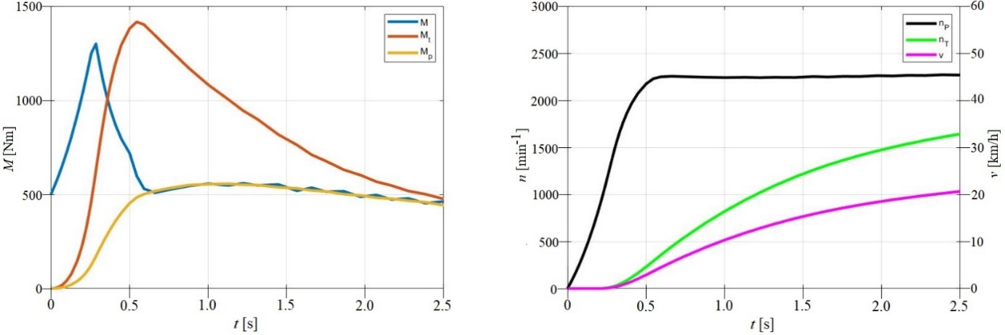

***Figure 1*** *The detail of waveforms of the obtained results, the time interval 0 to 2.5 s*

|  |  |
| --- | --- |
| **a)** | **b)** |

***Figure 2*** *Equivalent circuits for diagrams with one capacitance loop (a) and two capacitance loops (b)*

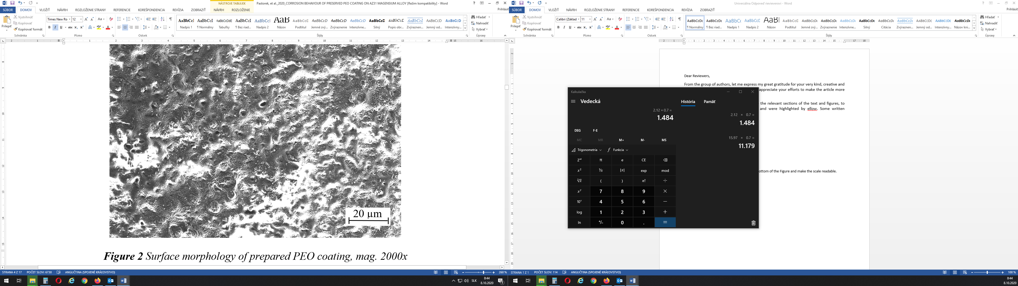

***Figure 3*** *Surface morphology of prepared PEO coating*

**3.2.2 Table formatting examples**

***Table 1*** *Electrochemical corrosion characteristics obtained from potentiodynamic curve of the PEO coating sealed by oil based preservation layer containing corrosion inhibitors on AZ31 in 0.1M NaCl solution*

|  |  |  |  |  |  |
| --- | --- | --- | --- | --- | --- |
| *Ecorr*  (mV) | *Epit*  (mV) | *icorr*  (µA.cm-2) | *βa*  (mV/dec~~k~~.) | *βc*  (mV/dec.) | *rcorr*  (µm.year-1) |
| -1568±22 | -1367±30 | 0.014±0.007 | 159±12 | 159±3 | 0.53±0.16 |

***Table 2*** *The main parameters used in the simulations*

|  |  |
| --- | --- |
| Data of the bridge | Data of the vehicle |
| *A =*8.865 m2 |  |

***Table 3*** *Analysis of diagrams of hydraulic shock absorbers on a stand at various working modes*

|  |  |  |  |  |  |
| --- | --- | --- | --- | --- | --- |
| Form of a diagram, when: | | | | Analysis of the resistance forces | Failure |
| *ve*1 = 0.04 - 0.06 m·s-1 | | *ve*2 = 0.08 - 0.10 m·s-1 | |  |  |
| Expansion | Compression | Expansion | Compression |  |  |
|  | |  | | A damper works properly, it is in good conditions.  Resistance forces are approximately the same under extension and compression. | |
| The small force in the compression | Few oil, contamination, leakage of safety and intake valves in the bottom |

**Acknowledgements**

Acknowledgements should be placed before references.

**Conflicts of interest**

The authors declare that they have no known competing financial interests or personal relationships that could have appeared to influence the work reported in this paper.

**References**

All information and data that are not author's original data or contribution shall be appropriattely and clearly referenced. All manuscripts are submitted for an originality check.

The numbered reference citation within text should be enclosed in square brackets and used in chronological order. The reference list should appear at the end of the article (in compliance with ISO 690).

For citing of multiple sources use [1, 5, 7] or [1-3] depending on the order of references you are using.

For one to three authors, list all authors in the reference, for four and more autors list the first author folowed by et al.

The following format shall be used for all references:

Journal paper

[1] HISAKATA, R., NISHIDA S., JOHNSTON, A. An adaptable metric shapes perceptual space. Current Biology [online]. 2016, 26(14), p.1911–1915 [accessed 2016-10-03]. ISSN 0960-9822. Available from: https://doi.org/10.1016/j.cub.2016.05.047

Book

[2] SAMBROOK, J., RUSSELL, D. Molecular cloning: a laboratory manual. 3. ed. Cold Spring Harbor, NY: CSHL Press, 2001. ISBN 0879695773.

Conference paper

[3] GROSS, P. Railway track cracks identification. In: 9th International Railway Conference: proceedings. Vol. 2. Mechanical engineering in transport. London: London College of Transport, 2001. ISBN 80-7157- 524-0, p. 262-268.

Edited book or monograph

[4] HOGUE, W. V. Structure databases. In: Bioinformatics. 2. ed. New York, NY: Wiley-Interscience, 2001, Life Sciences Series, p. 83–109. ISBN 0471383910.

Webpage

[5] Transport - Wikipedia [online] [accessed 2019-02-21]. Available from: https://en.wikipedia.org/wiki/Transport

**Annex**

List of needed annex, list and definition of uncommon abbreviations, ...